**H2ORDER: Smart Ordering and Monitoring for Water Refilling Stations Businesses in Nasugbu, Batangas**

**Prototype User Interface**

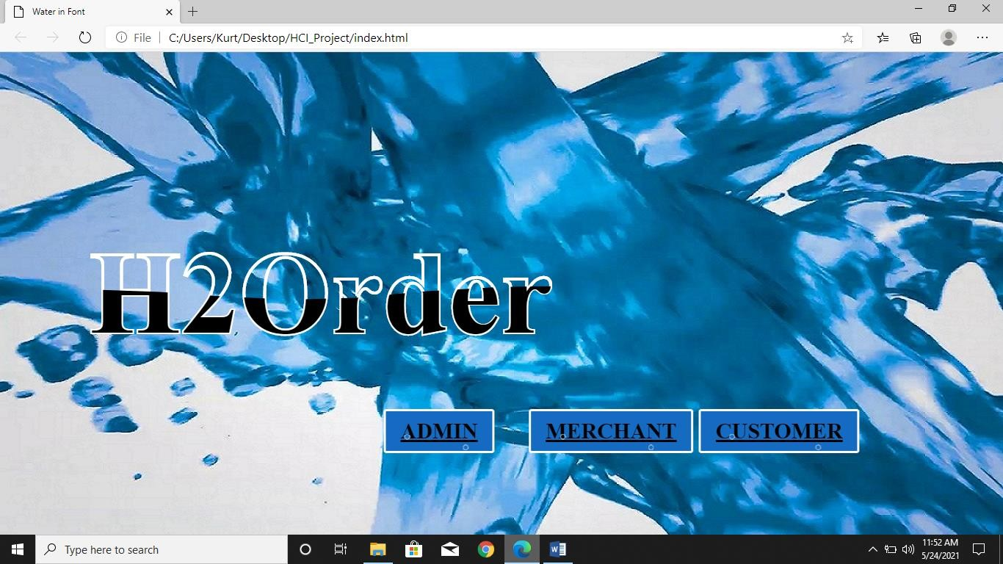

Figure 1. Main Interface

In this figure, the system user will decide if he/she will login as admin, merchant or customer.

Administrator Module

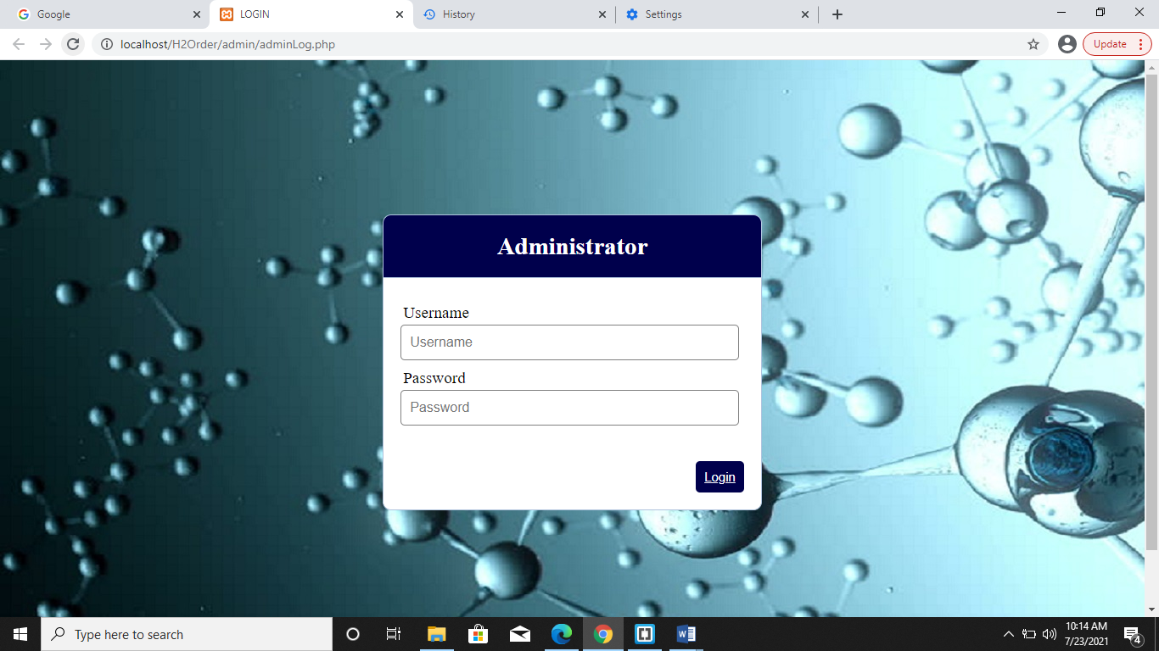

Figure 2. Admin Login Form

In figure 2, the system admin need to input his/her the username and password and click the login button to able to access the system.

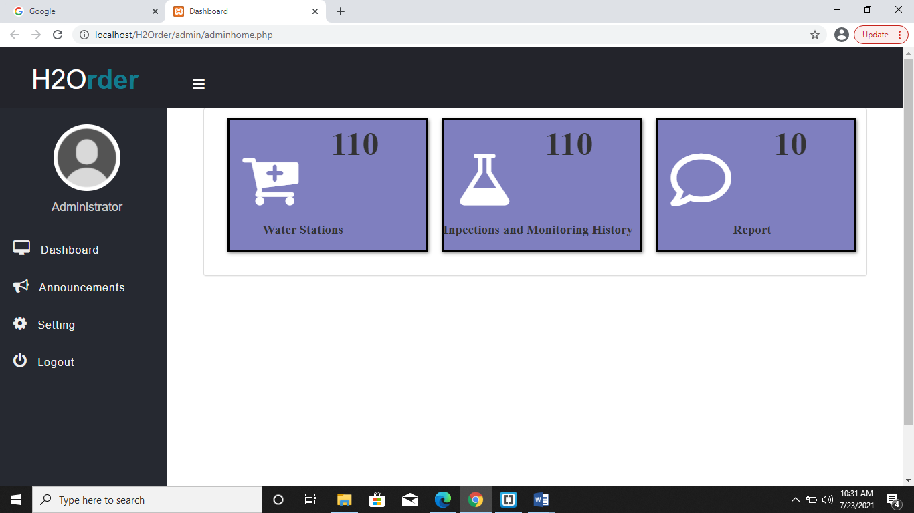

Figure 3. Admin Dashboard

In figure 3, it contains a summary of total numbers water stations that are registered in Sanitation office, total numbers of water station that passed in Alpha lab test, and lastly total numbers of customer reports about there complaints in water station.

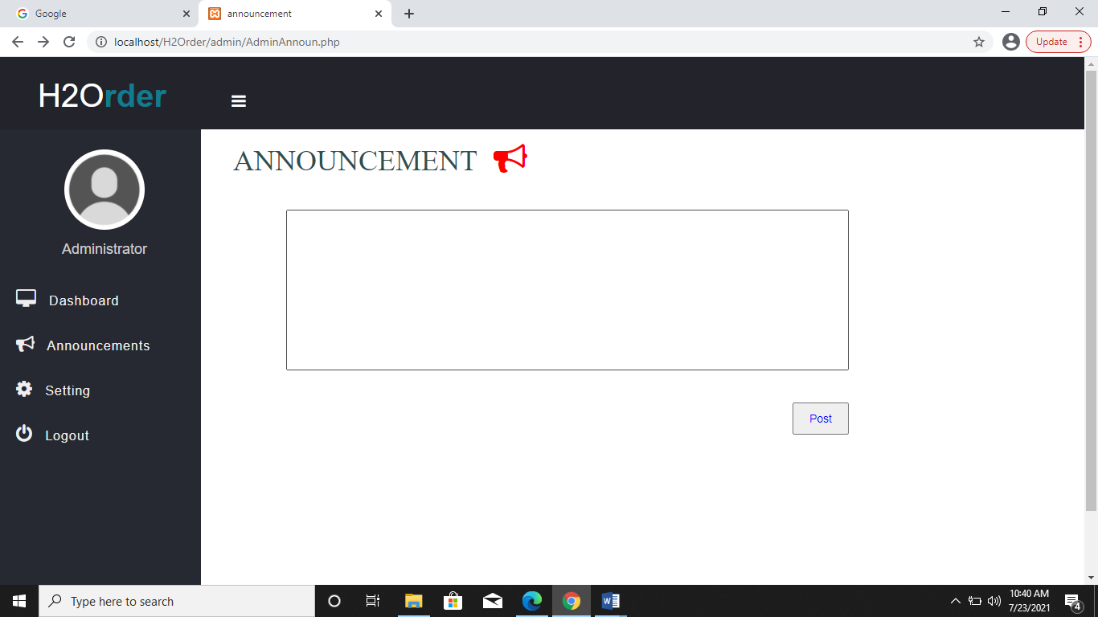

Figure 4. Announcements

In figure 4, Admin can give some announcement or updates that merchants can see.

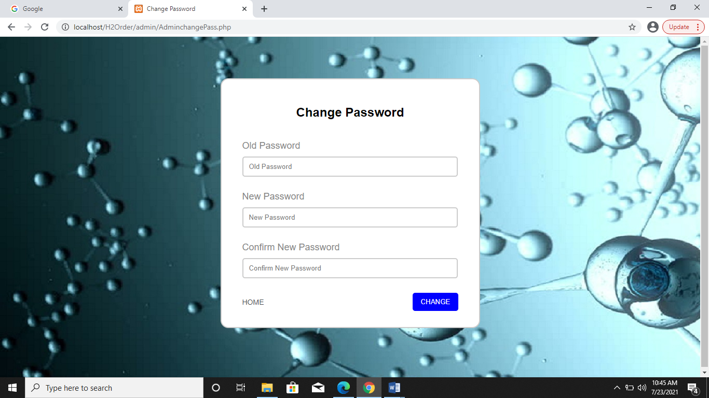

Figure 5. Admin Account Settings

In figure 5, the admin will able to input his/her old password and then he/she free to input again his new password after that you need to click the change button. As you can see in lower left of change password form there a home that if you click it will link you to the home page of the admin.

Merchant Module

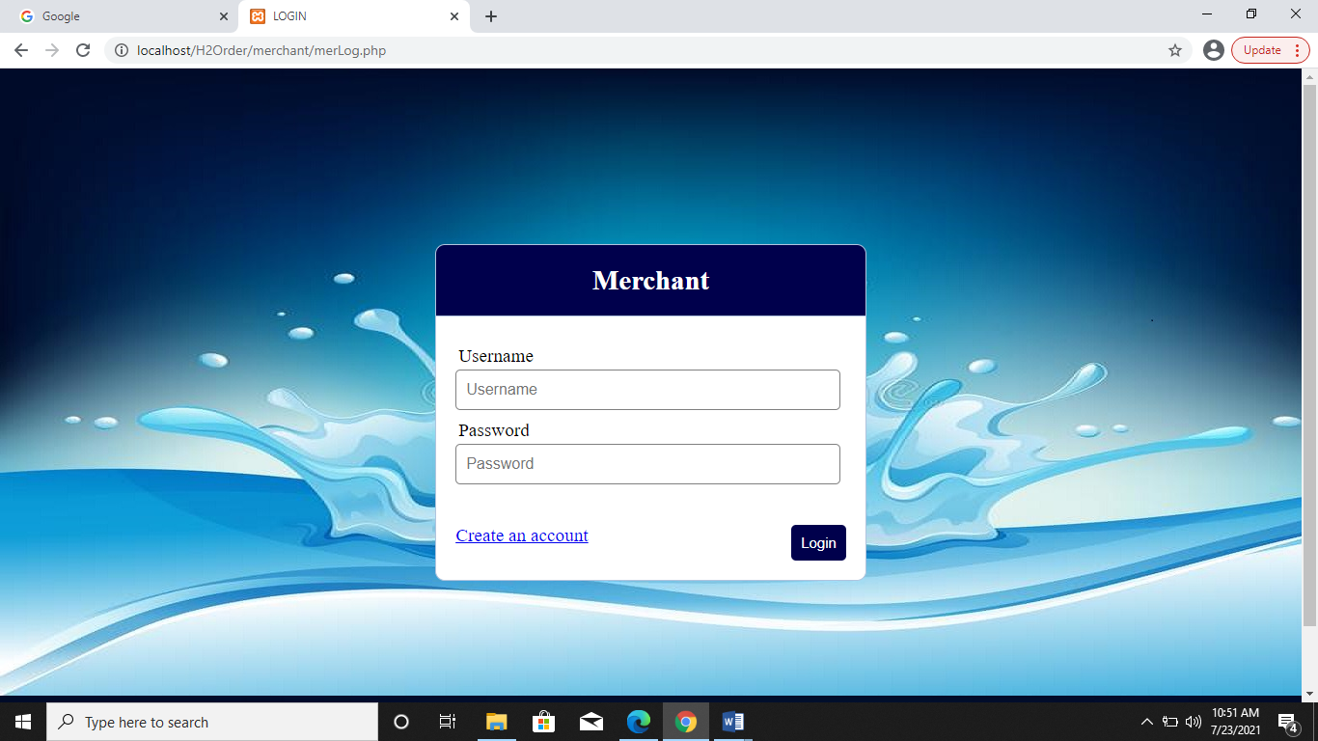

Figure 6. Merchant Login Form

In figure 6, the merchant will input his/her username and password after that you need to click the login button in the lower right part of login form to able to enter system.

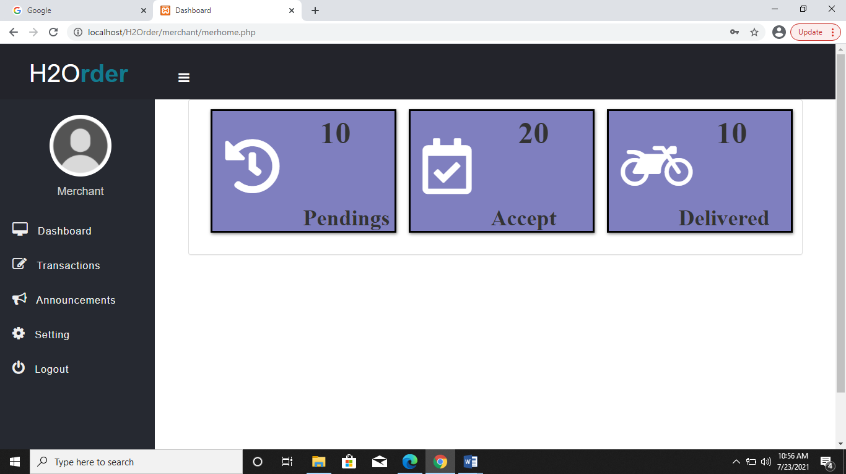

Figure 7. Merchant Dashboard

In figure 7, it contains a summary of total numbers of pending orders , total numbers of accepted customer orders, and lastly total numbers of delivered customer order.

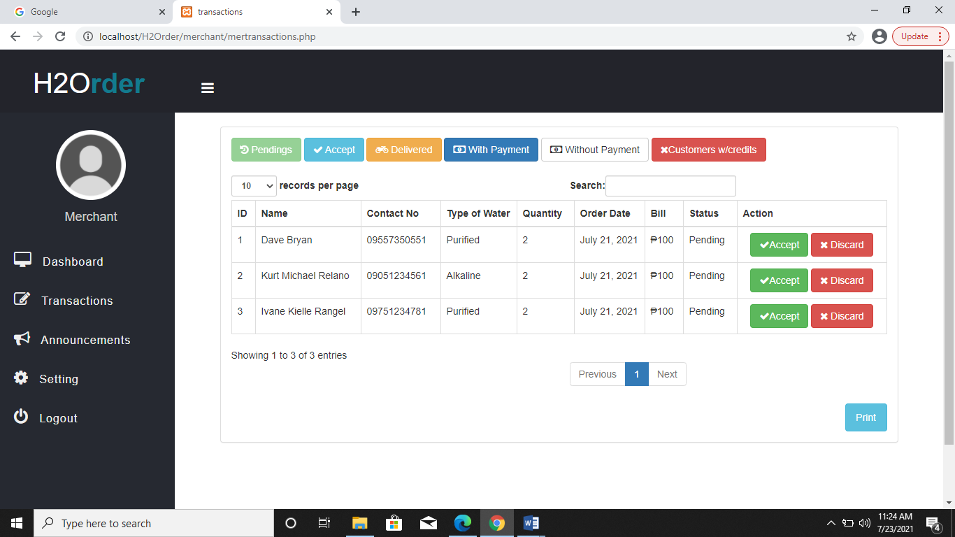

Figure 8. Merchant Pending Transactions

In the figure 8, it show the pending order details of the costumer and you can see in right corner there’s a two button which is accept and discard if the merchant have an option if he/she will accept or discard the transactions.

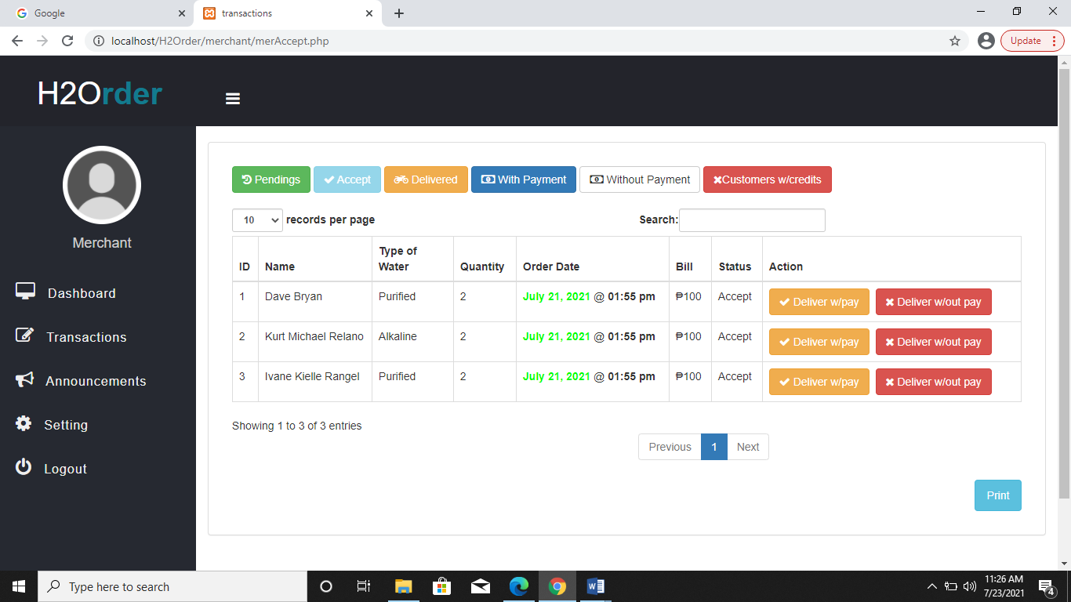

Figure 9. Merchant Accept Transactions

In figure 9, it show the accepted transactions coming from pending transactions.

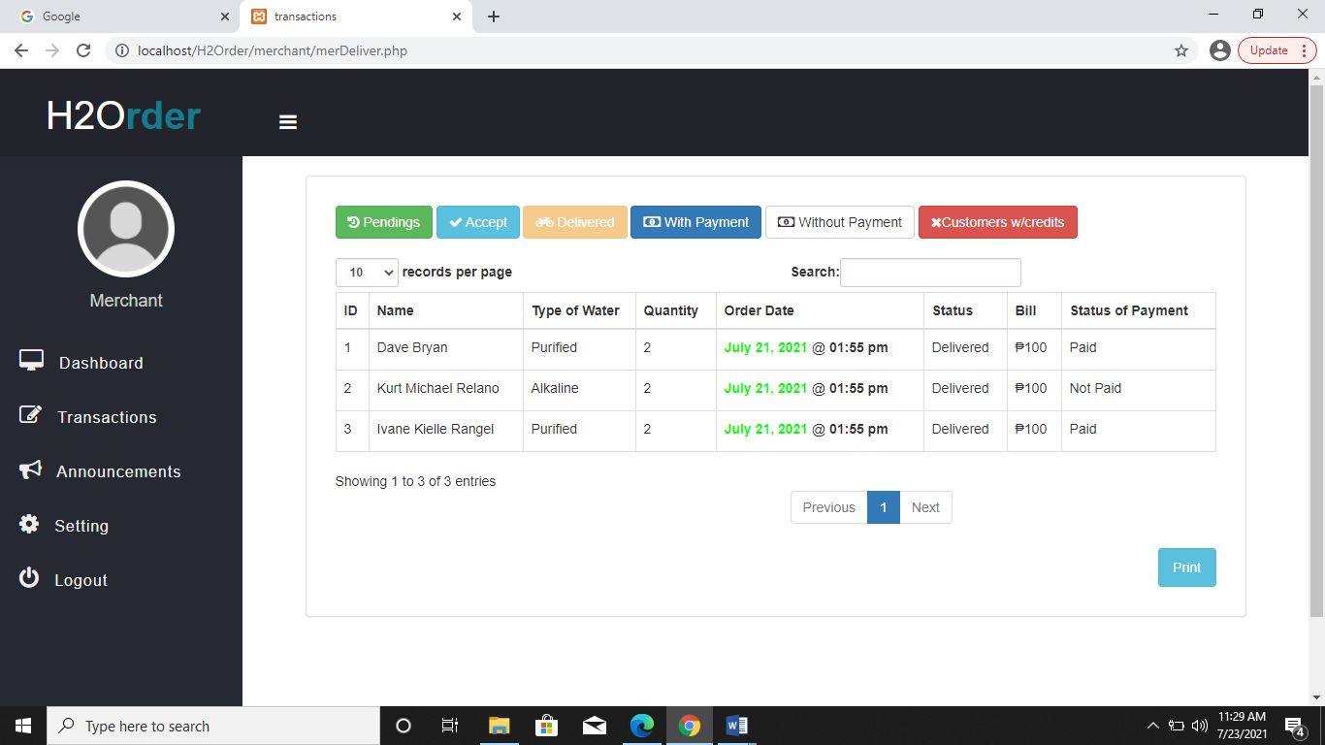

Figure 10. Merchant Delivered Transactions

In figure 10, merchants will generate reports regarding to the transactions and delivered products sent to customer by the order they placed.

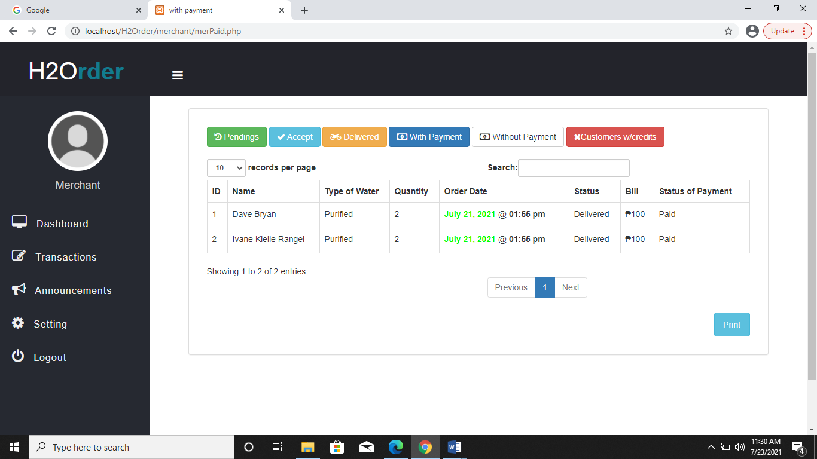

Figure 11. Merchant With Payment Transactions

In figure 11, merchants will have history of customers who pays for a specific date with their orders.

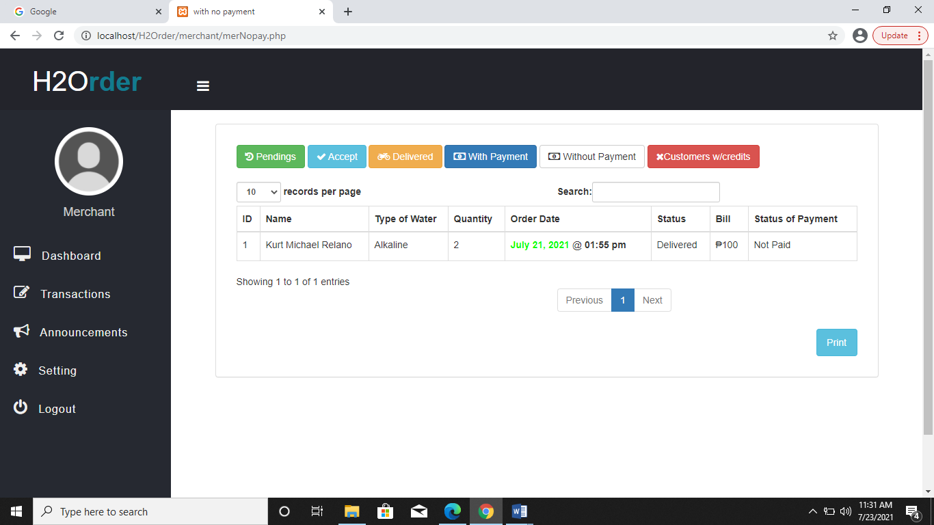

Figure 12. Merchant Without Payment Transactions

In figure 12, merchants will have history of customers who did not pay for a specific date with their orders.

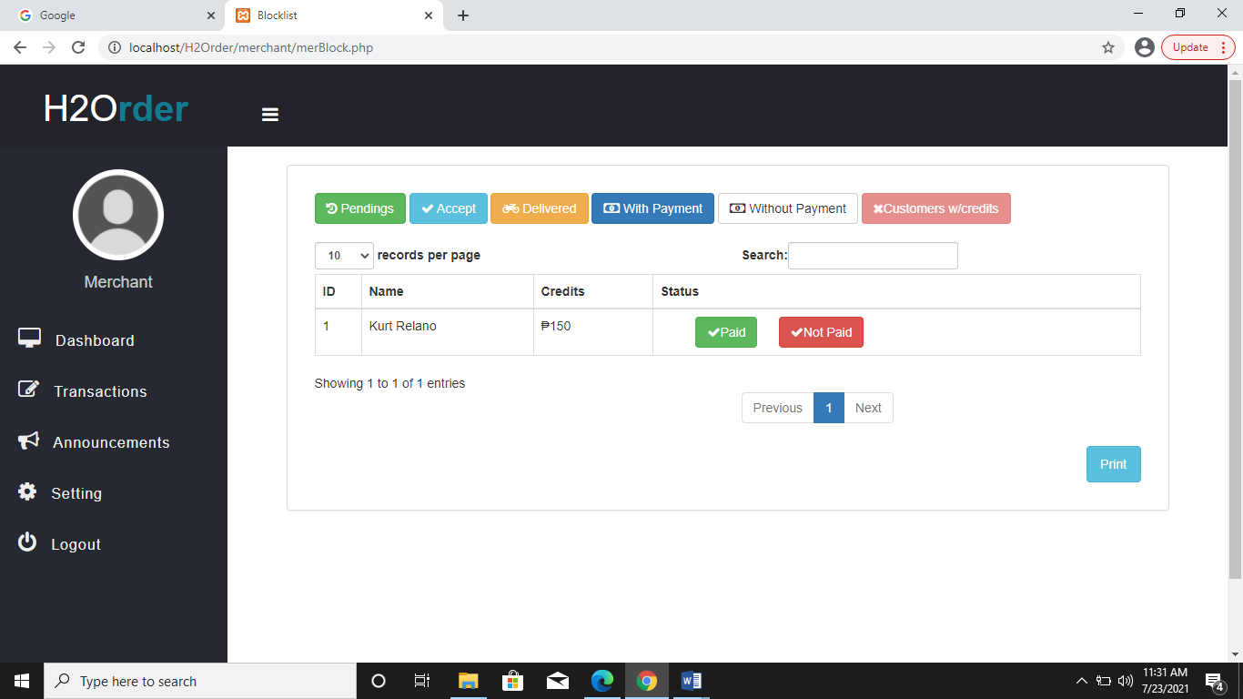

Figure 13. Merchant Customer’s with Credits

In figure 13, Merchants will have a list of customer’s with credits, this will serve as a reference for them and for the delivery man to ask some payment to customers.

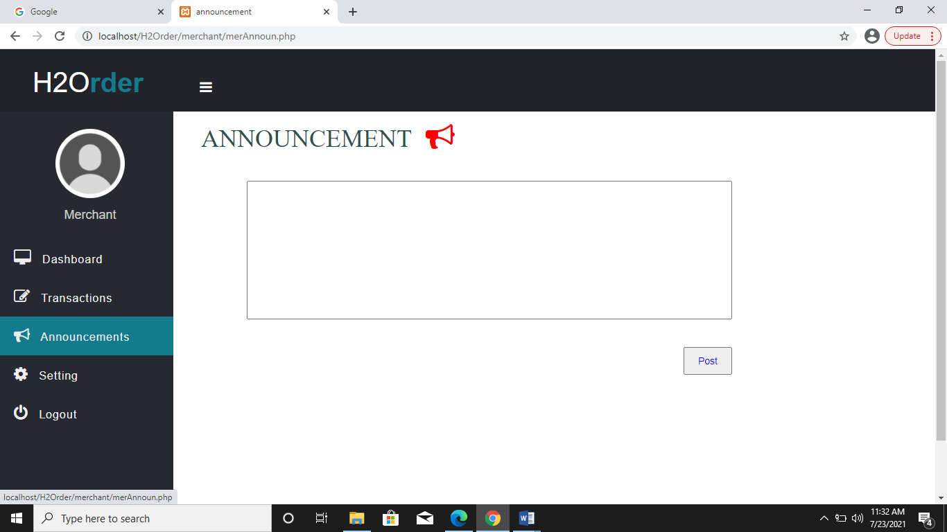

Figure 14. Merchant Announcements

In figure 14, Admin can give some announcement or updates that customer can see.

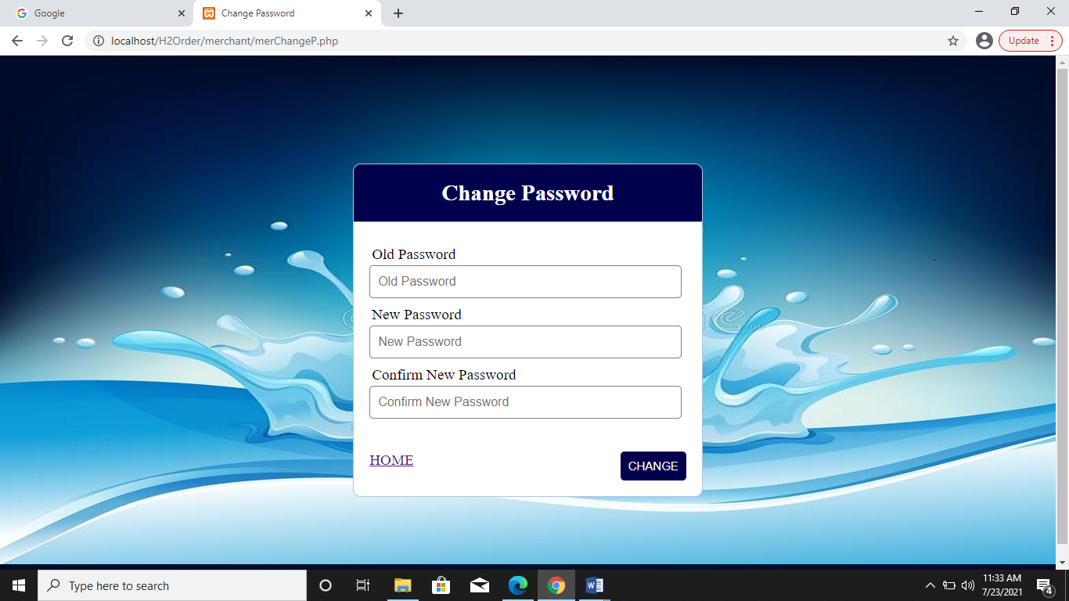

Figure 15. Merchants Account Settings

In figure 15, the admin will able to input his/her old password and then he/she free to input again his new password after that you need to click the change button. As you can see in lower left of change password form there a home that if you click it will link you to the home page of the merchants.

Customer Module

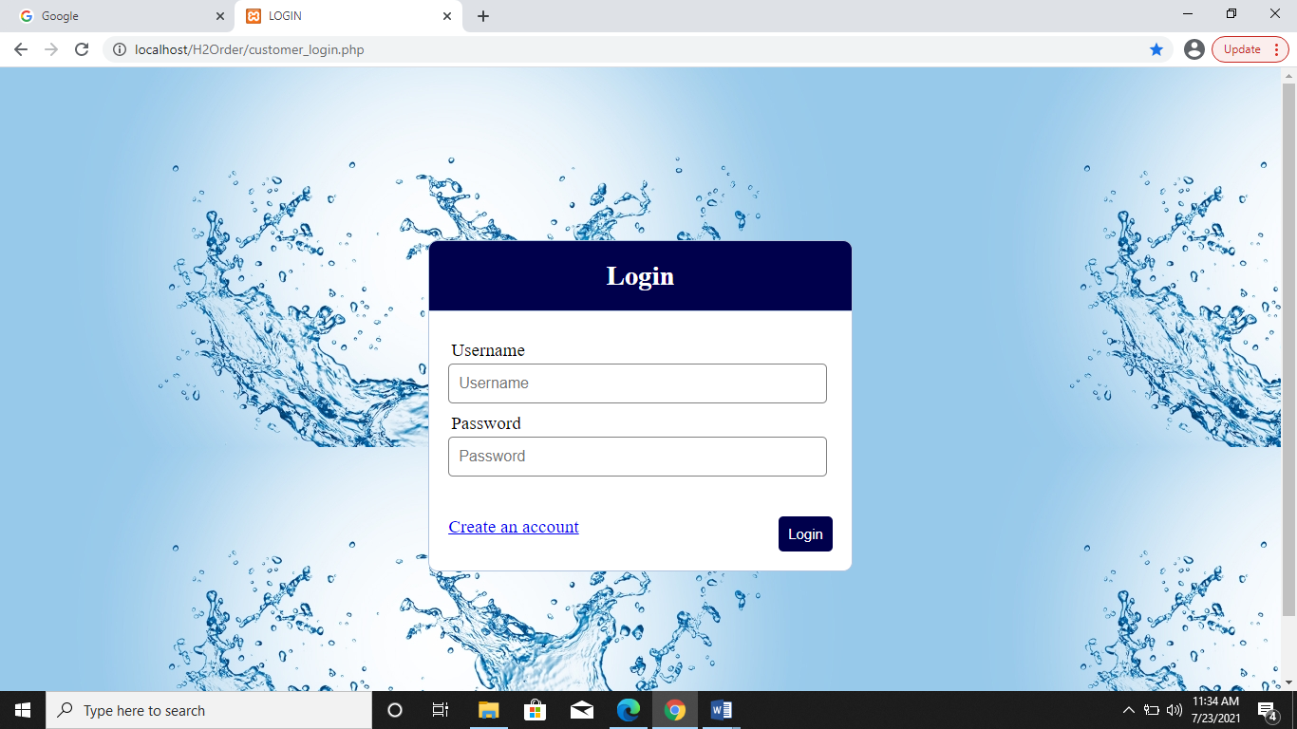

Figure 16. Customer Login Form

In figure 16, the customer will input his/her username and password after that you need to click the login button in the lower right part of login form to able to enter system and if the customer don’t have an account they just need to click the create an account in lower left part in login form so they will direct to the sign up form.

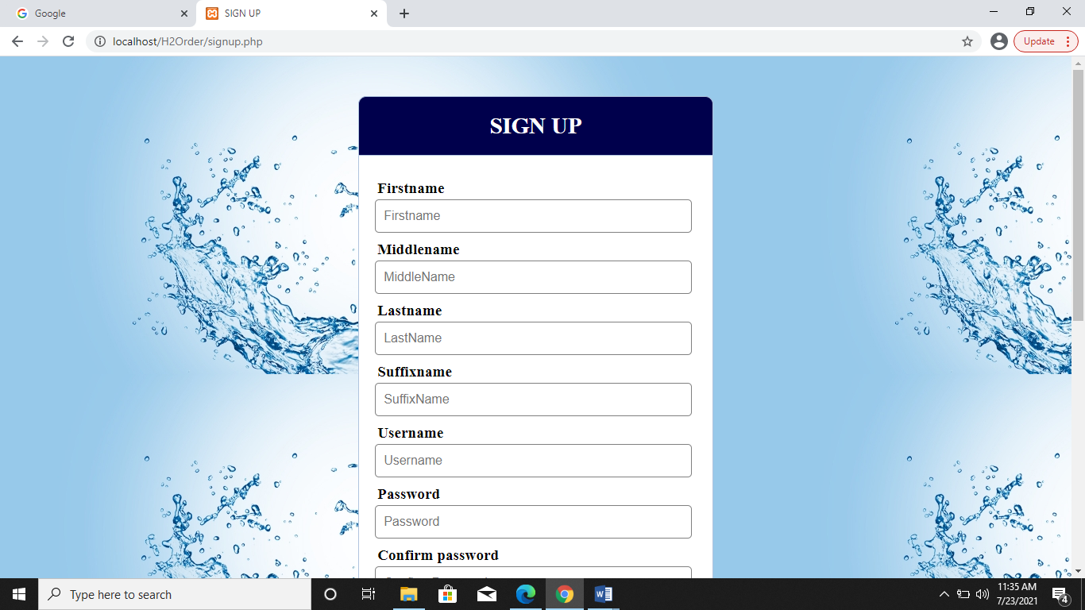

Figure 17. Customer Sign Up Form

In figure 17, you need to fill the basic information that the system need then you need to click the sign up button to successfully registered your account and after that just click the already have an account so the system will direct you back to the login form.

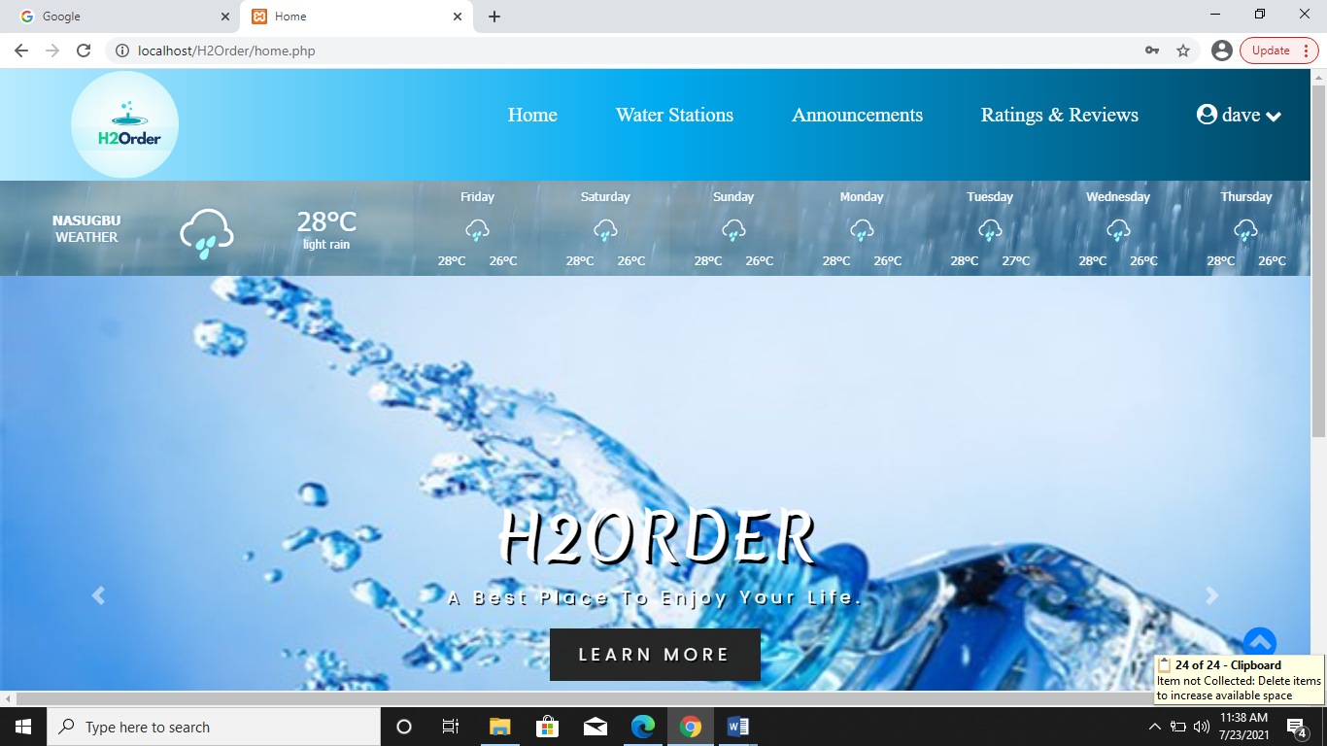

Figure 18. Customer Home Page

In this figure 18, we have some feature like the weather forecast also, If the admin or merchants have some announcements or updates the customer will see it.

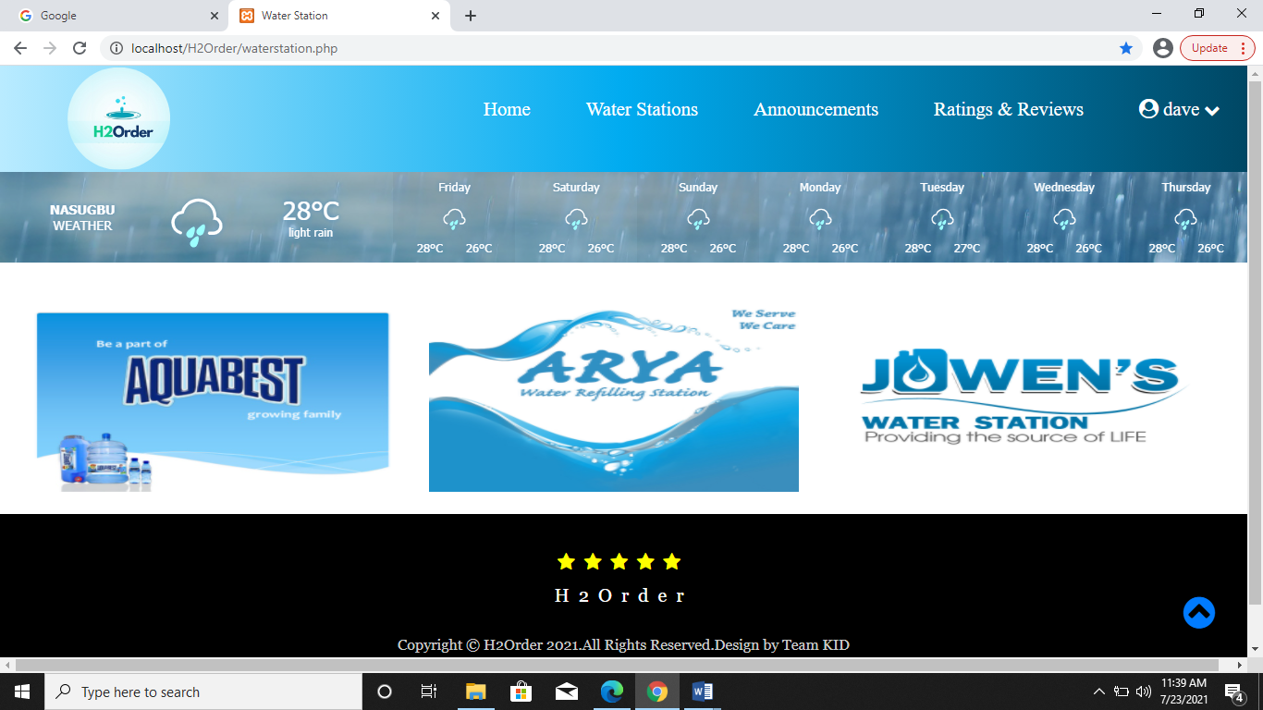

Figure 19. Water Stations

In this figure 19, it display all of the valid or registered water refiling stations in nasugbu that help the customer to choose what water refilling station or even pick the nearest water refiling station to lessen the time of delivery.

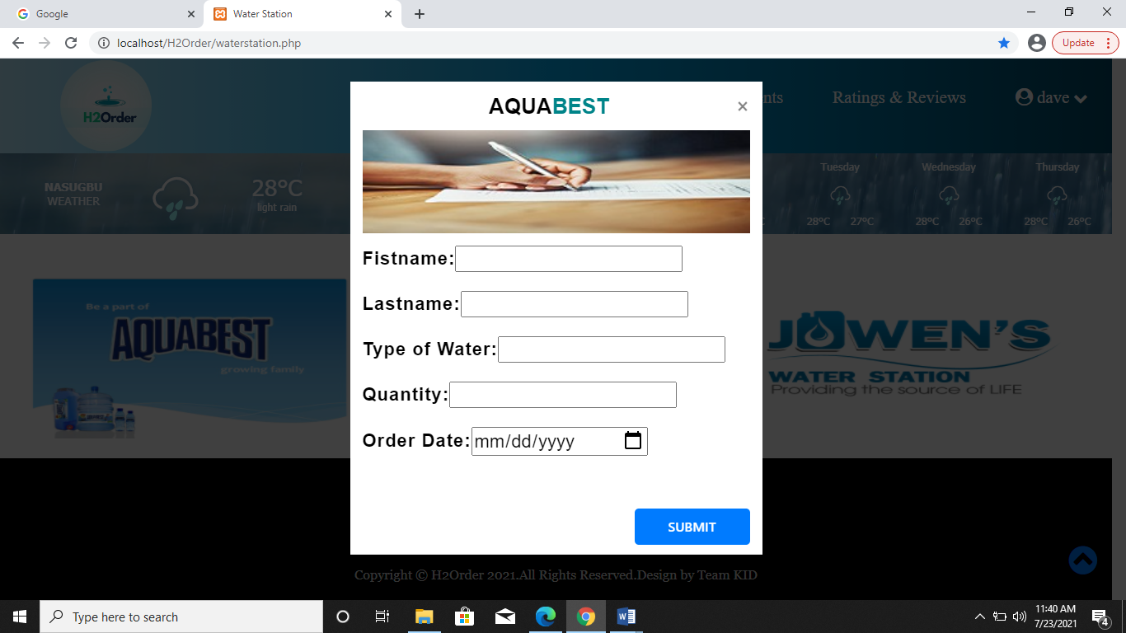

Figure 20. Customer Order

In this figure 20, this will be the ordering process which the customer need to fill up the form and also the type of water Alkaline or Purified.

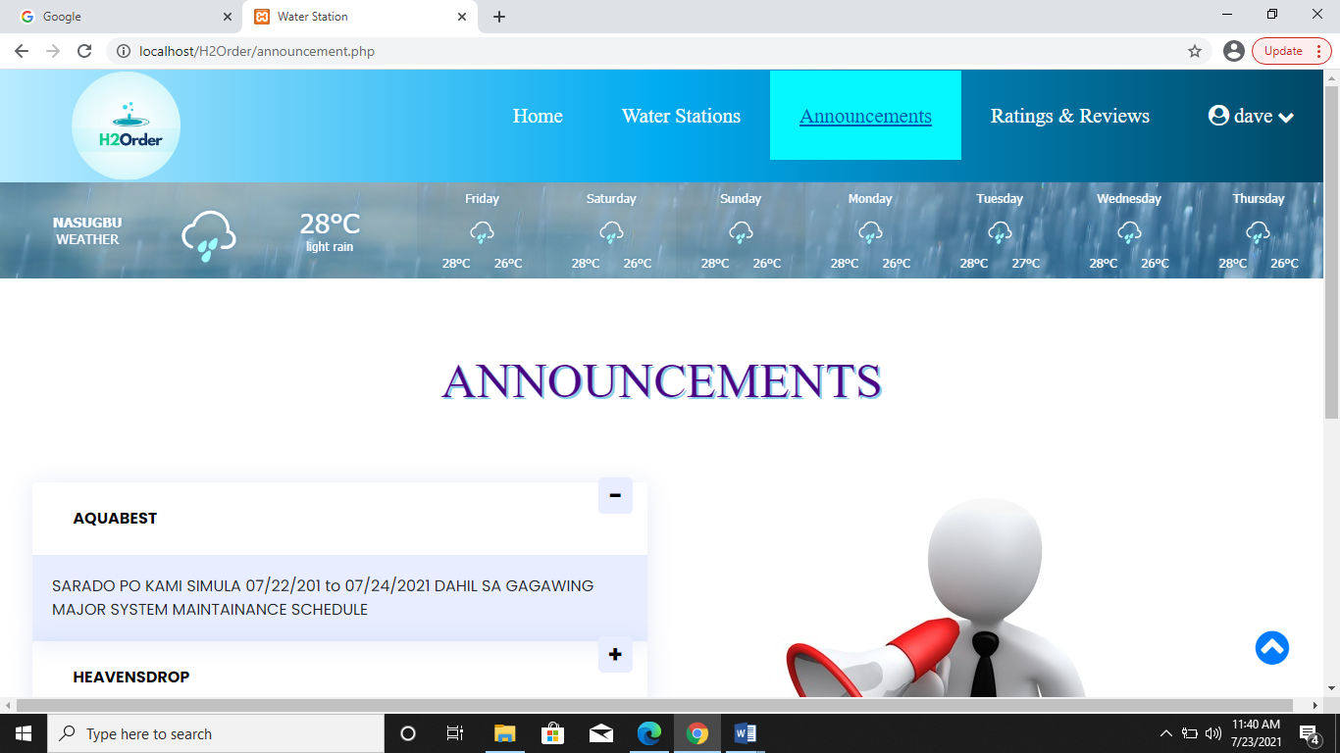

Figure 21. Announcements

In this figure 21, Admin and Merchants can give some announcement or updates that customer can see.

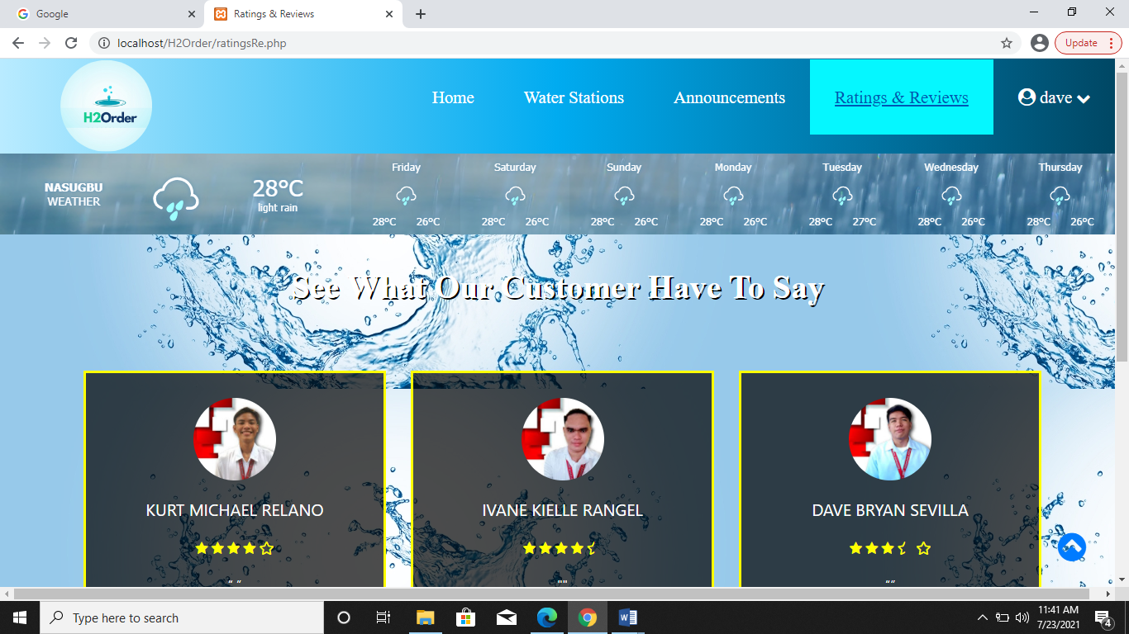

Figure 22. Rating and Reviews

In this figure 22, Customers can give feedback or comment to the water refilling stations that gives a better or even a worst service also, it can help to the inspection office to monitor the health protocol of the diff. workers or delivery man of the water refilling stations.

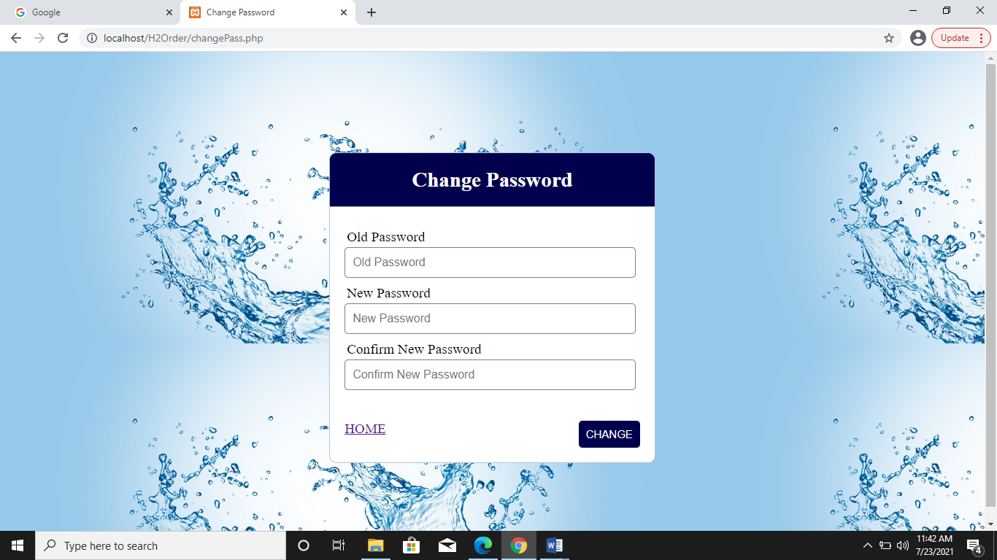

Figure 23. Customer Account Settings

In this figure 23, Customer Account Settings will help the user’s to modify or to update their passwords.